Chromebook Troubleshooting

Having issues with your school-issued chromebook?
Ms. Jones in the Media Center can help during 2nd block, but FIRST you need to fill out the following Google Form:

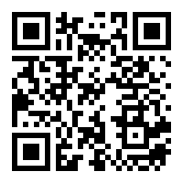
https://forms.gle/5oMYF1vNTwNYeVMz8

DISCLAIMER: You must sign in with your school-issued Google account. Also, Ms. Jones is only available to assist with troubleshooting needs during 2nd block. If you fill the Google Form out at a time other than second block, she will get with you the next day to work on the issue.
Thanks for your patience!

